**DANANG SOFTWARE CORPORATION**

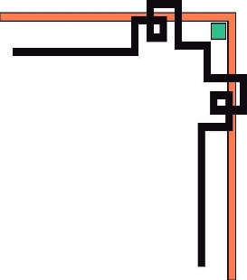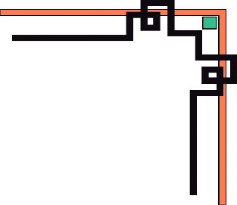

**SOFTECH-APTECH**



EProject :

MARINA FLEET

Guiding faculty : NGUYEN VIET HUYNH

Members :

* LE DUC HUY (LEADER)
* NGUYEN VAN ANH MINH

Group : 02

Batch : 155

**Da Nang, 15th November 2019**

**TEACHER’S EVALUATION**

………………………………………………………………………………………………………………………………………………………………………………………………………………………………………………………………………………………………………………………………………………………………………………………………………………………………………………………………………………………………………………………………………………………………………………………………………………………………………………………………………………………………………………………………………………………………………………………………………………………………………………………………………………………………………………………………………………………………………………………………………………………………………………………………………………………………………………………………………………………………………………………………………………………………………………………………………………………………………………………………………………………………………………………………………………………………………………………………………………………………………………………………………………………………………………………………………………………………………………………………………………………………………………………………………………………………………………………………………………………………………………………………………………………………………………………………………………………………………………………………………………………………………………………………………………………………………………………………………………………………………………………………………………………………………………………………………………………………………………………………………………………………………………………………………………………………………………………………………………………………………………………………………………………………

**I. ACKNOWLEDGEMENT.**

At first, our group would like to deeply thank to Mr. Nguyen Viet Huynh , who helped and facilitated us during the project.

In process of working, due to limitations of time and experience so we couldn’t avoid being errors. But with Mr.Huynh’s guiding, our project would be better than we expected.

While working, we have used most of information from these sources:

- Student book, ebook.

- Technologies: HTML5, CSS3, Bootstrap, JavaScript, Jquery.

- Some website:

+ [*http://pixabay.com*](http://pixabay.com)

**II. ANALYZING PROJECT.**

1. **Introduction.**

Marina Fleet website presents the information about many fleets or yatchs and boats available with them. Customer can look for which boat they want and rent them.

1. **Home page.**

As the site's main page , it contains important information and links to the other pages.

1. **Features (Categories)**

This page is used to looking for all products, which are categorized into 4 types: Luxury, Fishing, Sailing and Sport.

1. **News.**

Events page show many information about festivals in Da Nang and nearby cities.

1. **Events.**

Events page show many information about festivals in Da Nang and nearby cities.

1. **Gallery.**

Gallery page is a collection of photoes and videos which were taken by both our customers and the company while our products be using.

1. **Service.**

Customer can buy or rent boats from these pages (Buying, Boating). They can also watch new products at Showroom and reading some comparisons at Compare.

1. **Customer.**

At customer page, visiters can create account so information about them could be saved. Those information are about customer and products that they rented or renting.

1. **Customer.**

About us page presents information about our company . It also contains contact form for visiters and company address displayed using GoogleMaps.

1. **Site map.**

Site map gives customers a fully sight about the website. In this page, there are all links to connect to other pages.

**III. PROJECT PLANNING.**

|  |  |  |  |  |  |  |
| --- | --- | --- | --- | --- | --- | --- |
| ***NO.*** | **TASK** | **START** | **END** | **MEMBER** | **LEVEL** | **STATUS** |
| ***1.*** | Analyzing | 25/09 | 25/09 | All | High | Finished |
| ***2.*** | Planning | 27/09 | 27/09 | All | High | Finished |
| ***3.*** | Designing | 28/09 | 28/09 | All | High | Finished |
| ***4.*** | Searching materials | 30/09 | 10/10 | All | Medium | Finished |
| ***5.*** | Home page | 01/10 | 05/10 | Huy | High | Finished |
| ***6.*** | News/Events | 01/10 | 05/10 | Cuong | Medium | Finished (Huy) |
| ***7.*** | Features | 06/10 | 10/10 | Huy | Medium | Finished |
| ***8.*** | Gallery/Service | 06/10 | 10/10 | Cuong | Medium | Finished (Huy) |
| ***9.*** | Customer | 01/10 | 05/10 | Minh | High | Finished |
| ***10.*** | About | 06/20 | 10/10 | Minh | Medium | Finished |
| ***11.*** | Add up codes and sources | 11/10 | 12/10 | Minh | High | Finished |
| ***12.*** | Complete and correct website | 13/10 | 15/10 | Huy | High | Finished |
| ***13.*** | Writing Document | 16/10 | 18/10 | Minh | Medium | Finished |

**IV. DESIGNING.**

1. 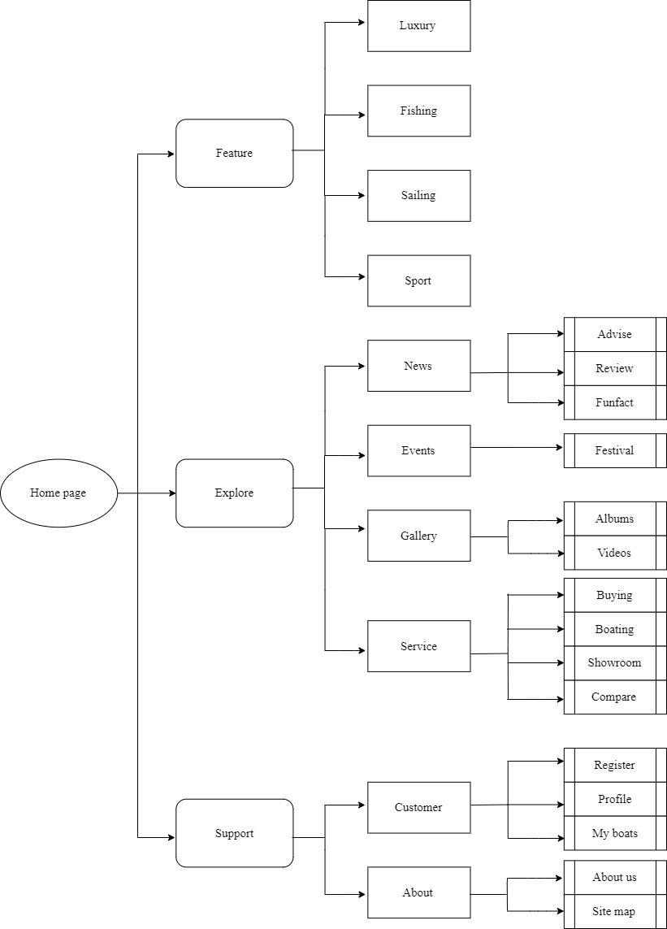**Site map.**
2. **Layout**

**Home page**

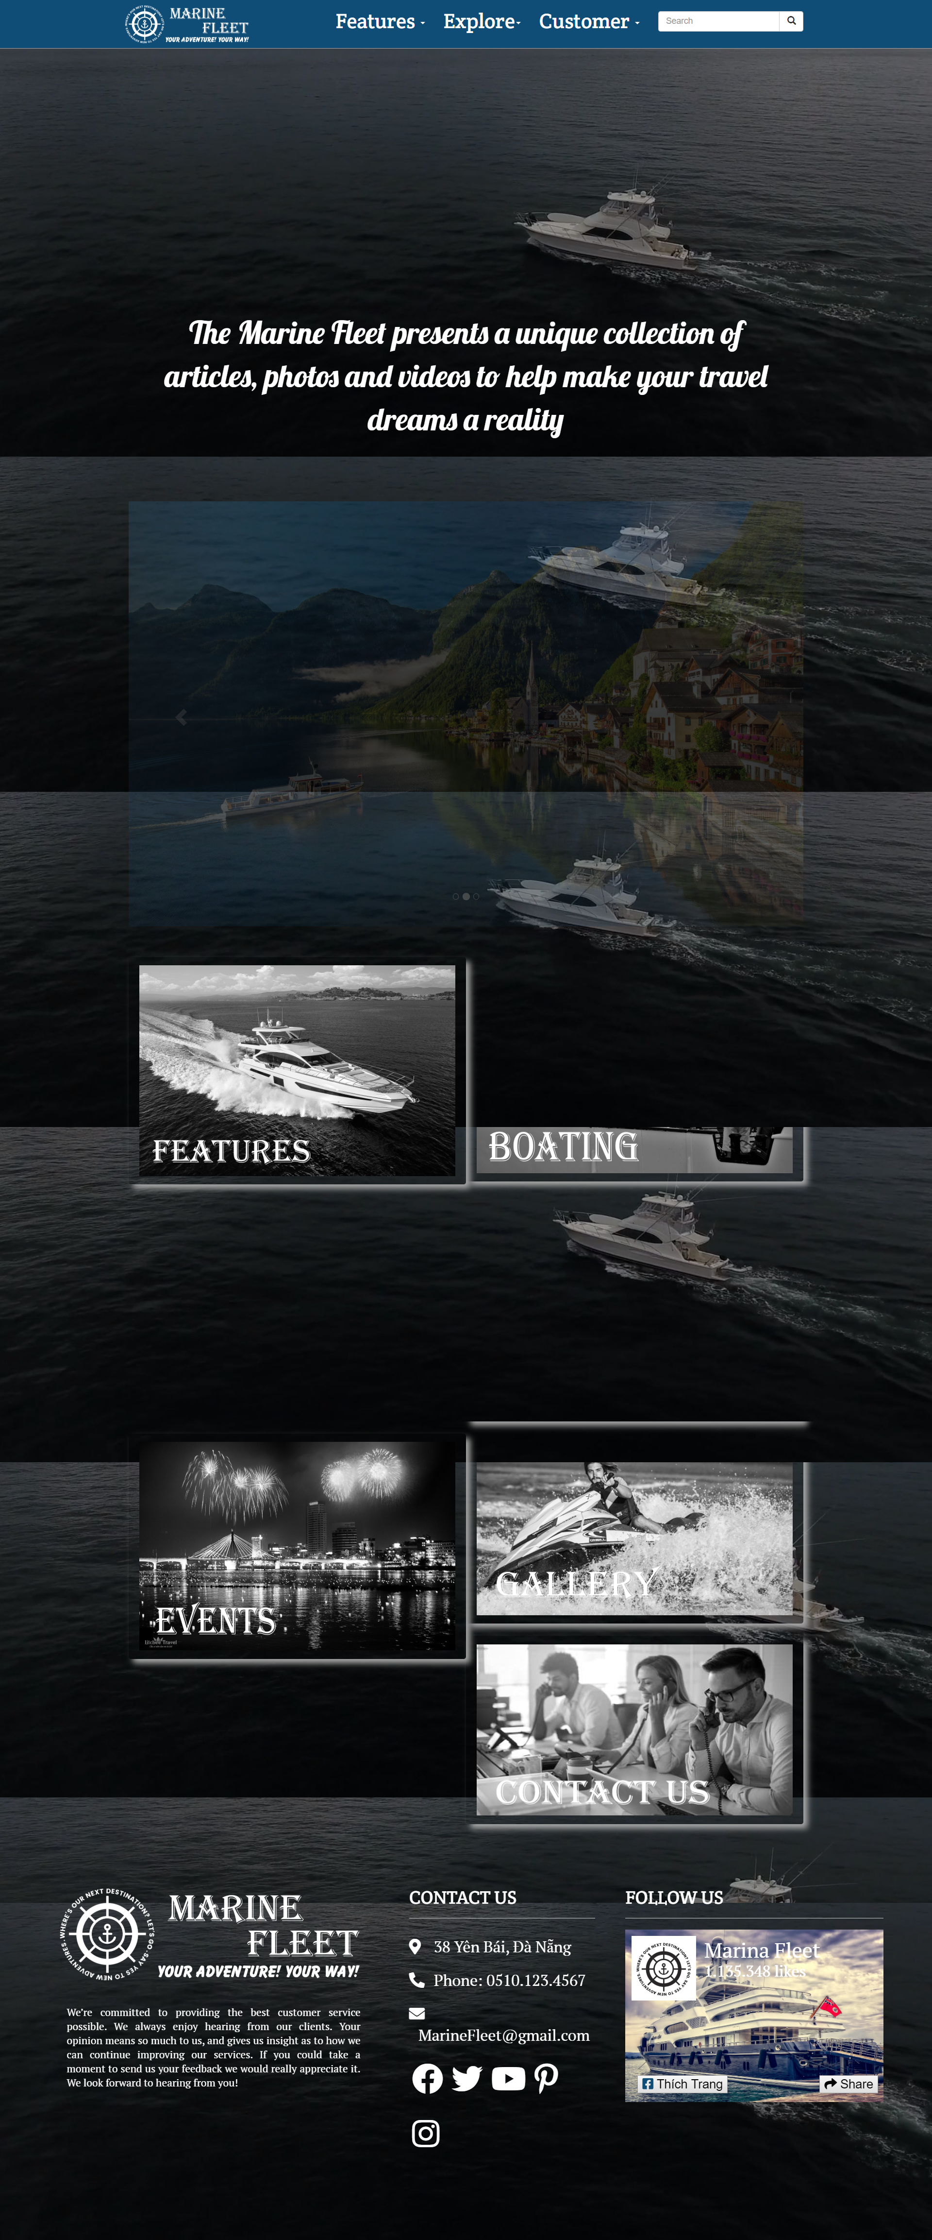

**Feature(Categories)**

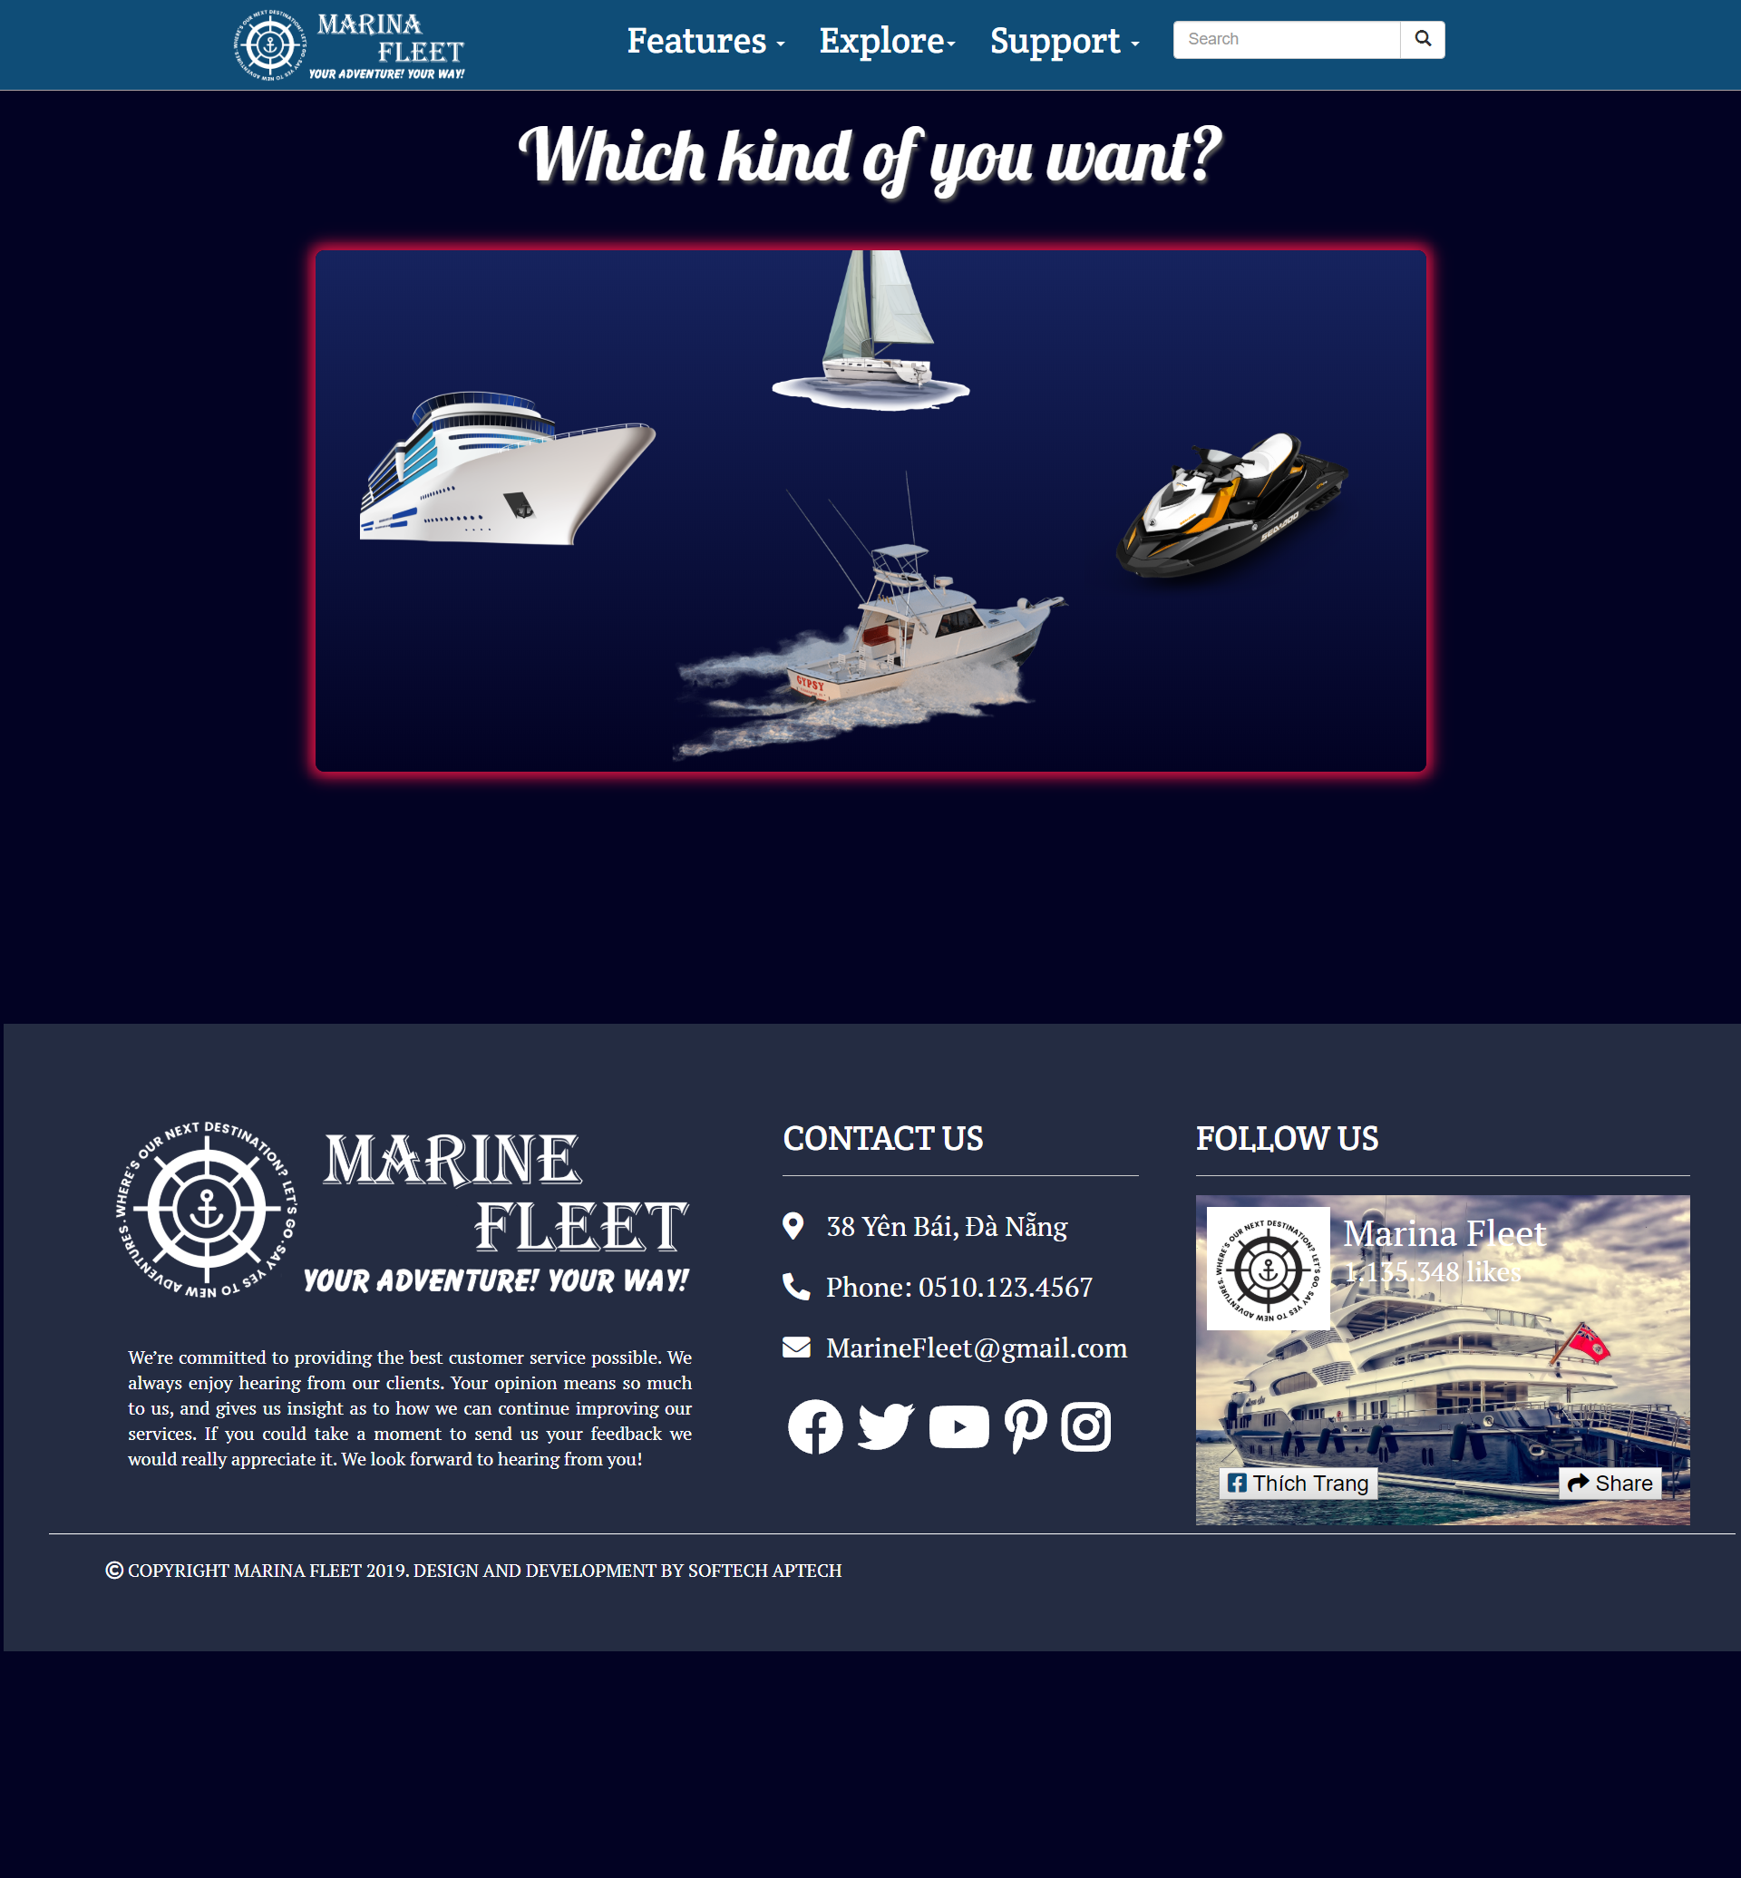

**News/Events**

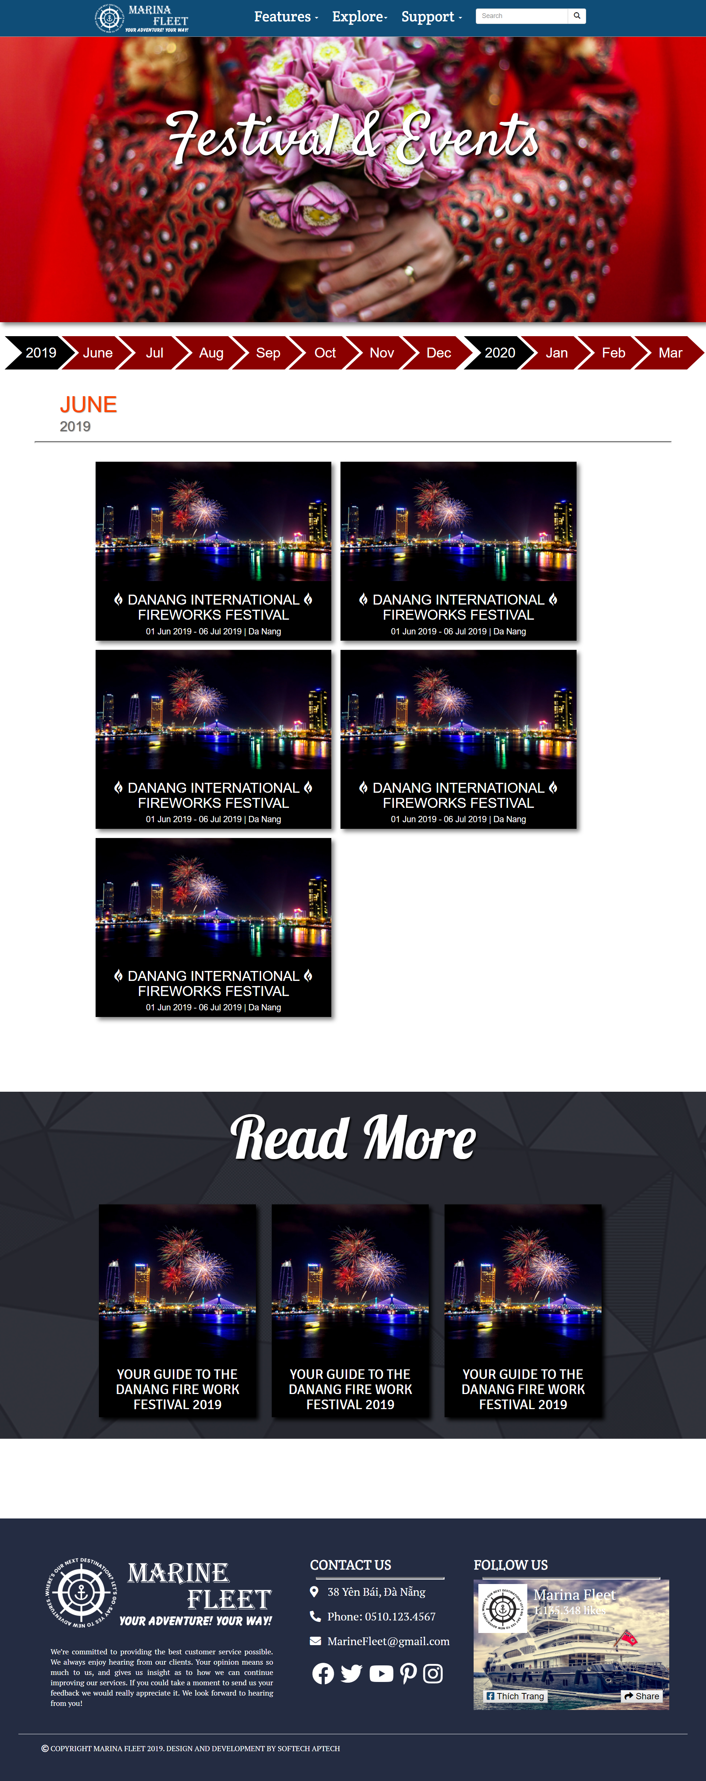

**Gallery**

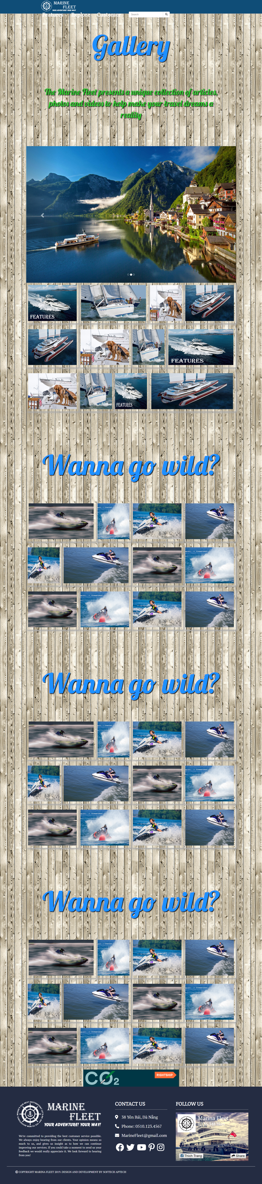

**Customer – My boats**

**About us**

**V. GUI PROTOTYPE**

**Home page**

**Features(categories)**

**News**

**Events**

**Gallery**

**Customer- Profile**

**Customer – My boats**

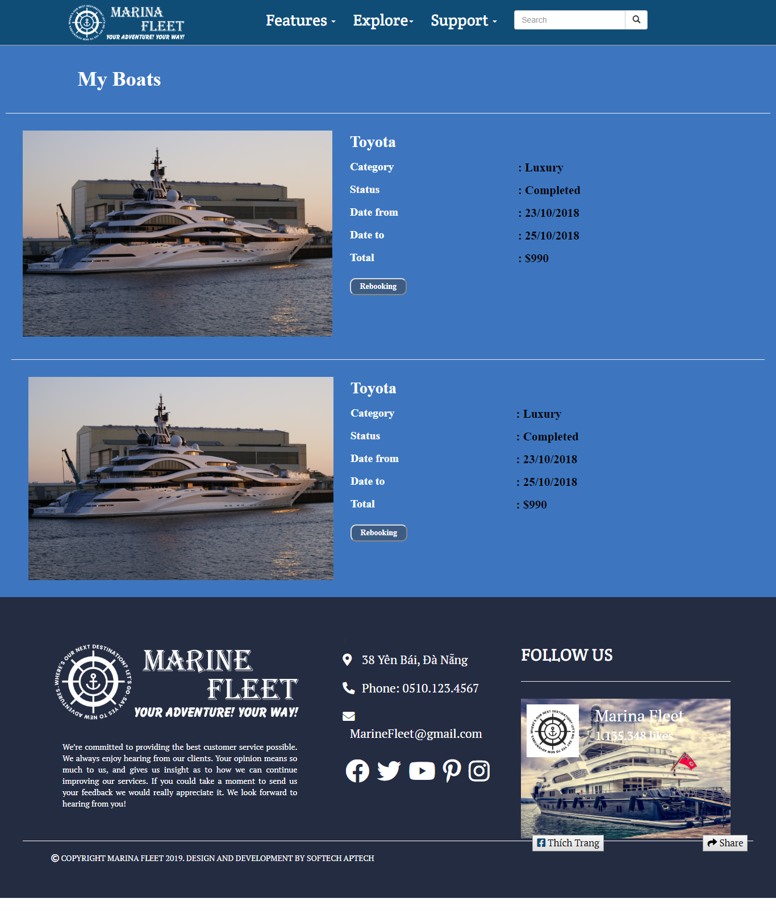

**About us**

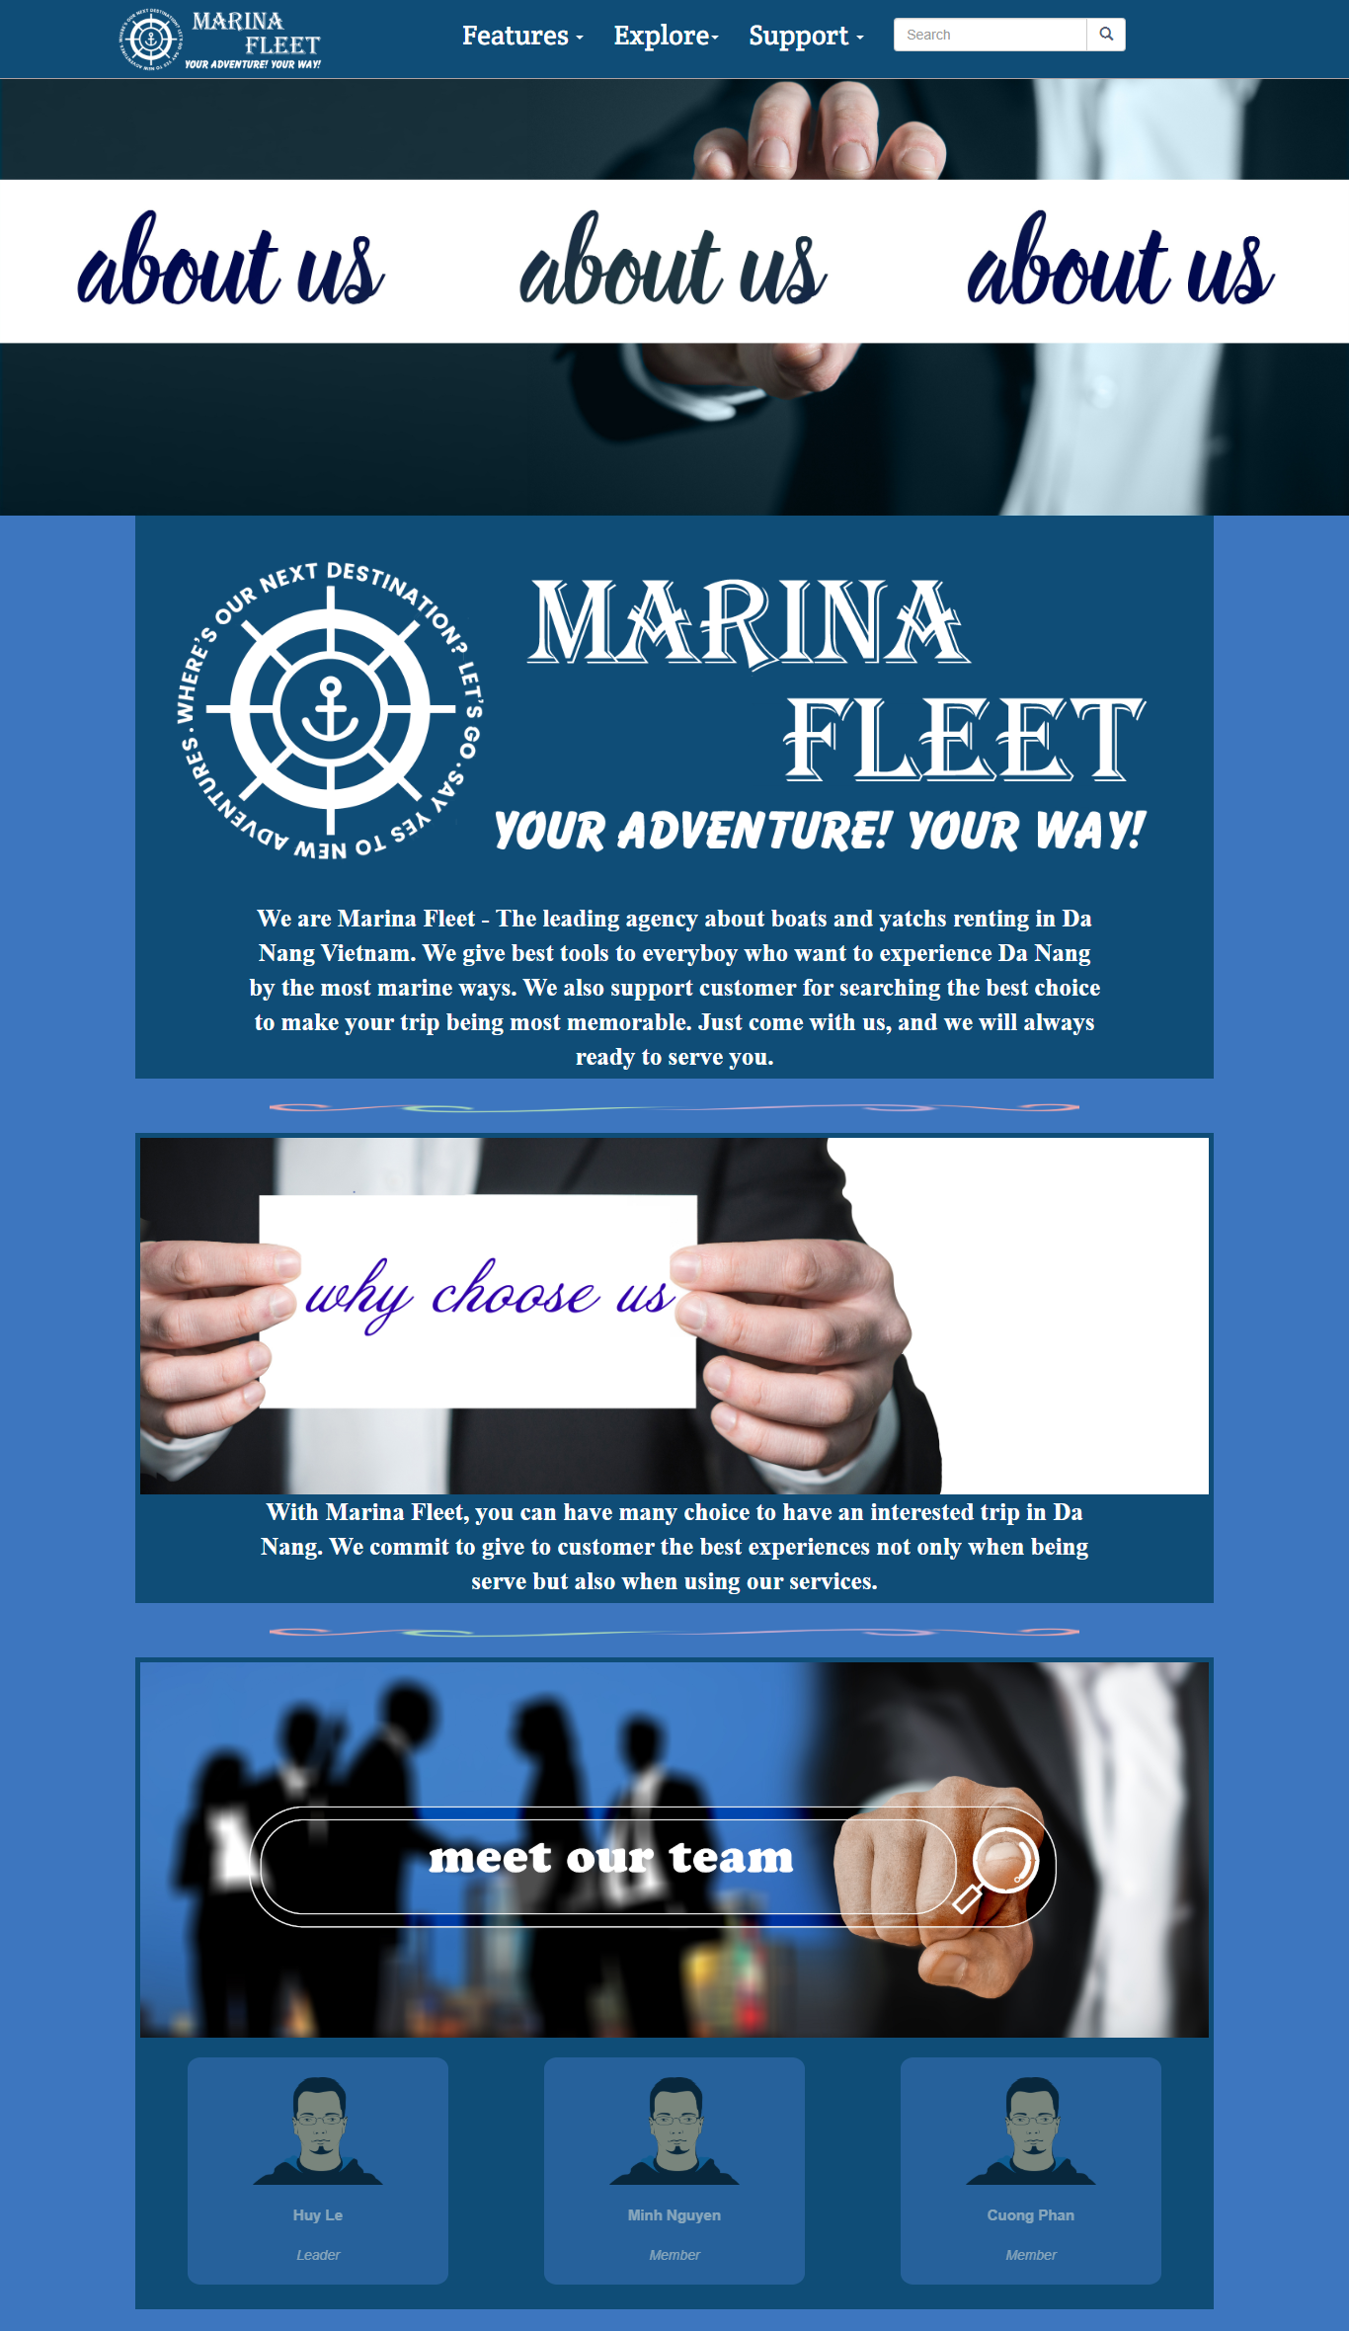

**About us(2)**

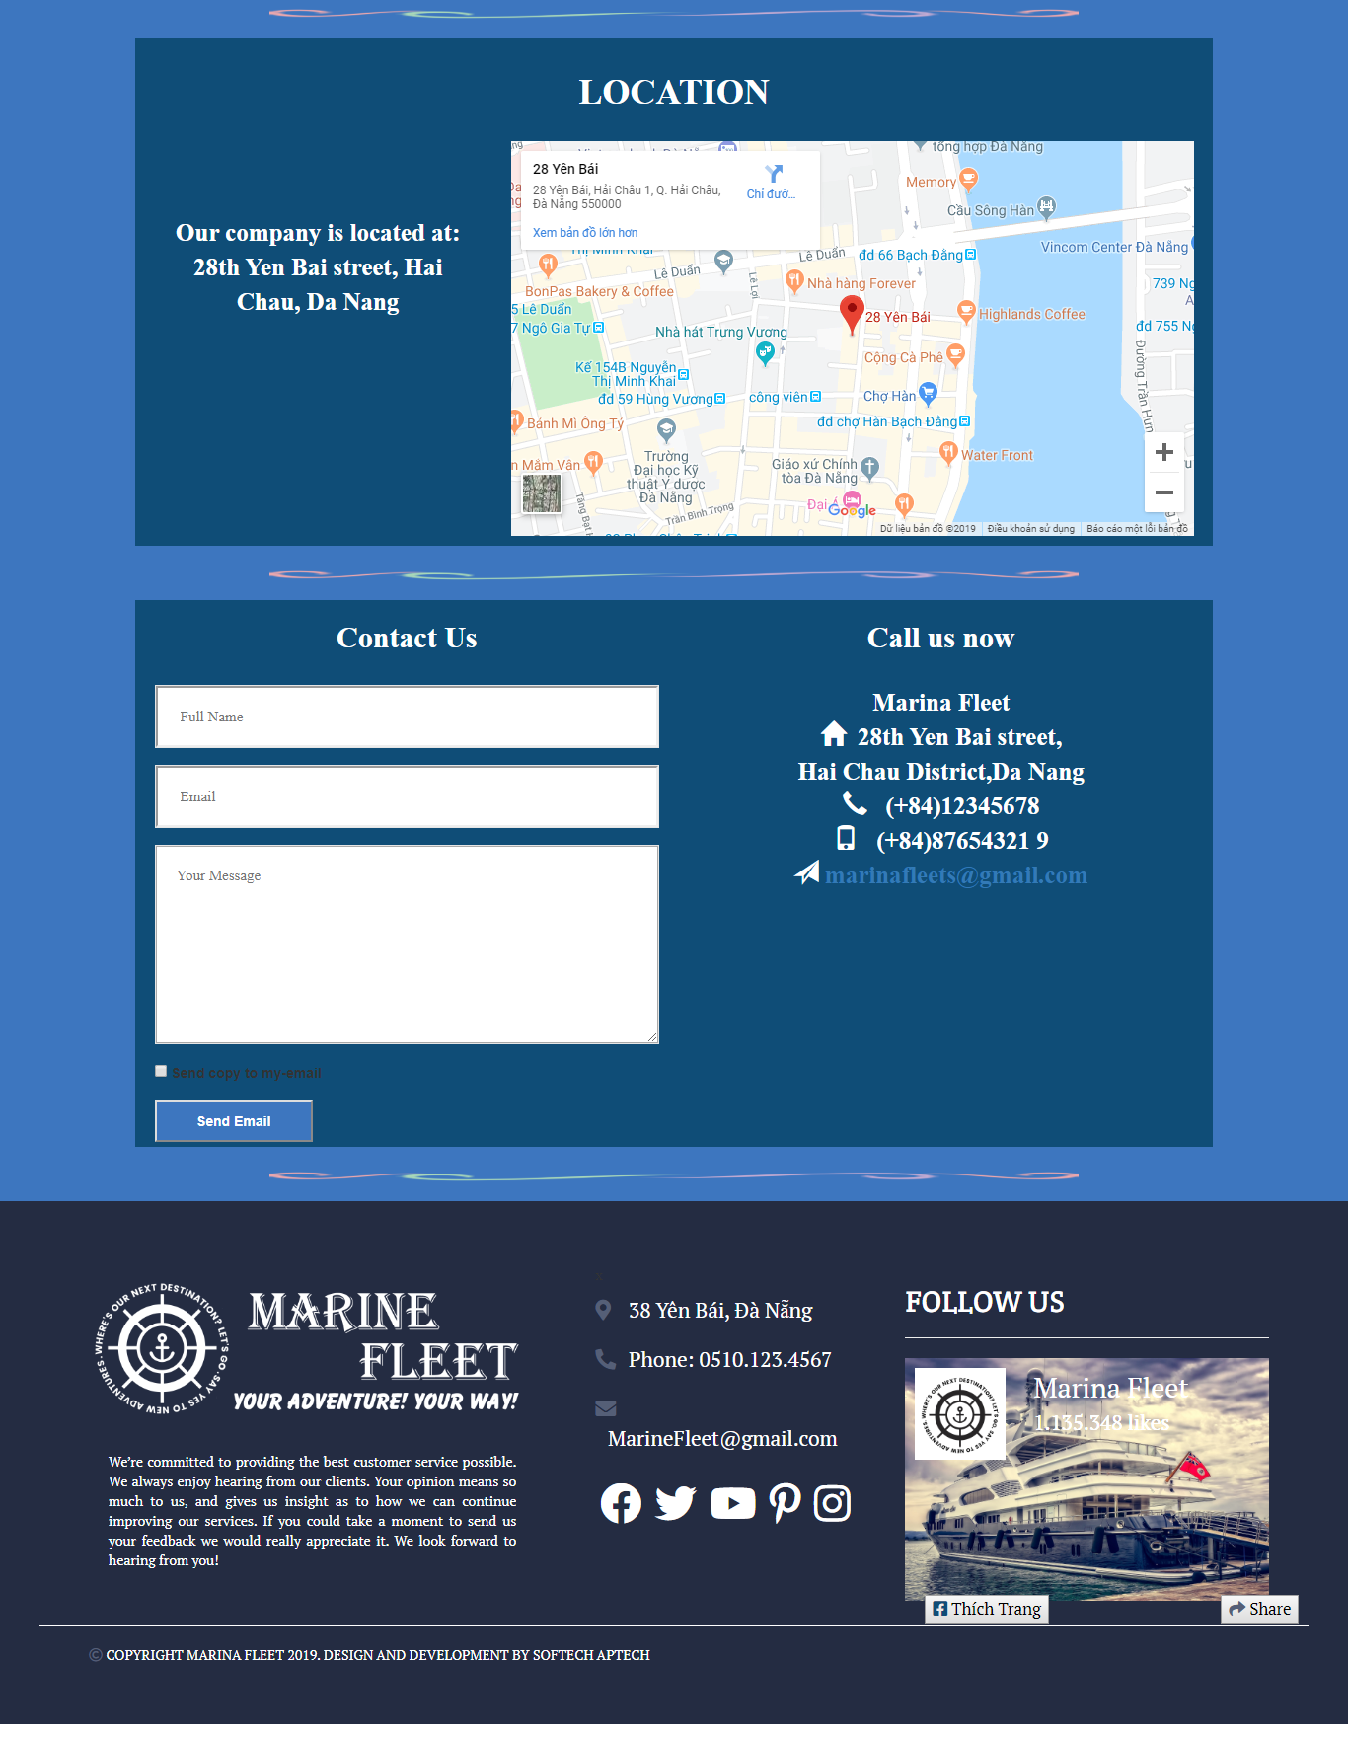

**Site map**

